**Title:**

Property Management Analytics Project — Yardi Lite

**Subtitle:**

An end-to-end SQL and Power BI case study designed to demonstrate data-driven decision-making in property management.

**Objective:**

To analyze property management operations — including financials, occupancy, maintenance, and sustainability — using SQL for data querying and Power BI for visualization, aligning with Yardi’s PropTech analytics approach.

**Tools & Technologies**

Database: MySQL

Visualization: Power BI

Data Size: 30 records

Skills Demonstrated: SQL Joins, Subqueries, Aggregations, Conditional Logic, Data Cleaning, Dashboard Design

**PROJECT STRUCTURE**

|  |
| --- |
| **1. Data Exploration** |

|  |
| --- |
| Cleaned and standardized fields like Occupancy_Rate and Compliance_Flag for consistency. |

**2. SQL Analytics**

Executed 9 curated SQL queries covering compliance, occupancy, financial, and sustainability metrics.

|  |
| --- |
| **3. Dashboard Design** |

|  |
| --- |
| Created 4 dashboards — *Property Overview*, *Financial Insights*, *Operational Insights*, and *Project Summary.* |

|  |
| --- |
| **4. Storytelling & Insights** |

|  |
| --- |
| Delivered insights that can guide investor focus, compliance improvement, and energy cost management. |

**KEY DASHBOARDS**

1. **Property Overview**

Displays property distribution, occupancy, rent averages, and compliance ratios.

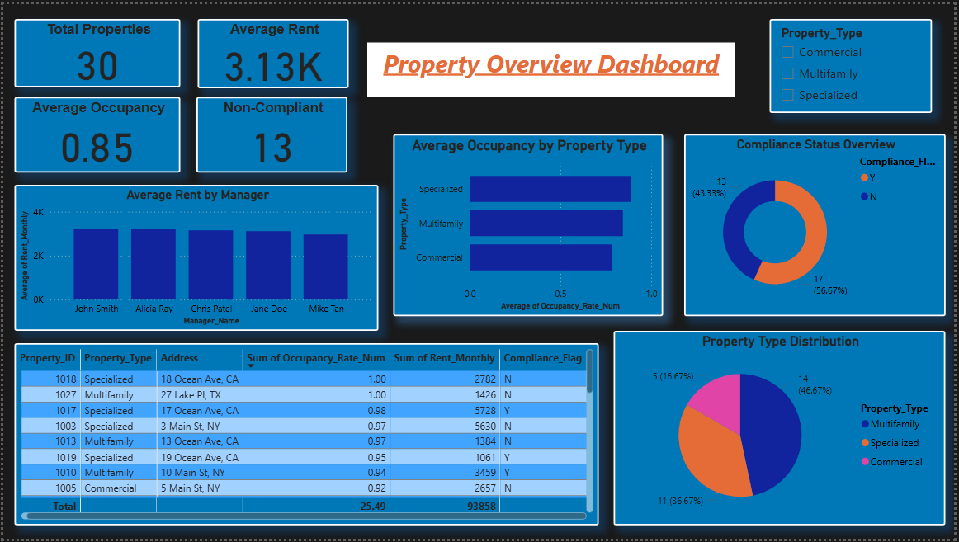

1. **Financial Insights**

Shows investment values, rent trends, and energy cost performance.

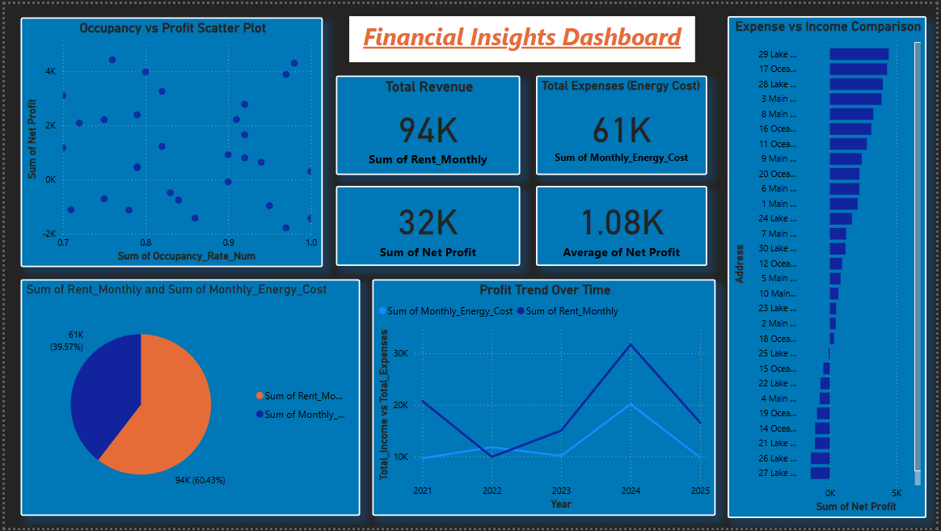

1. **Operational Insights**

Tracks maintenance status, AI feature use, and compliance updates.

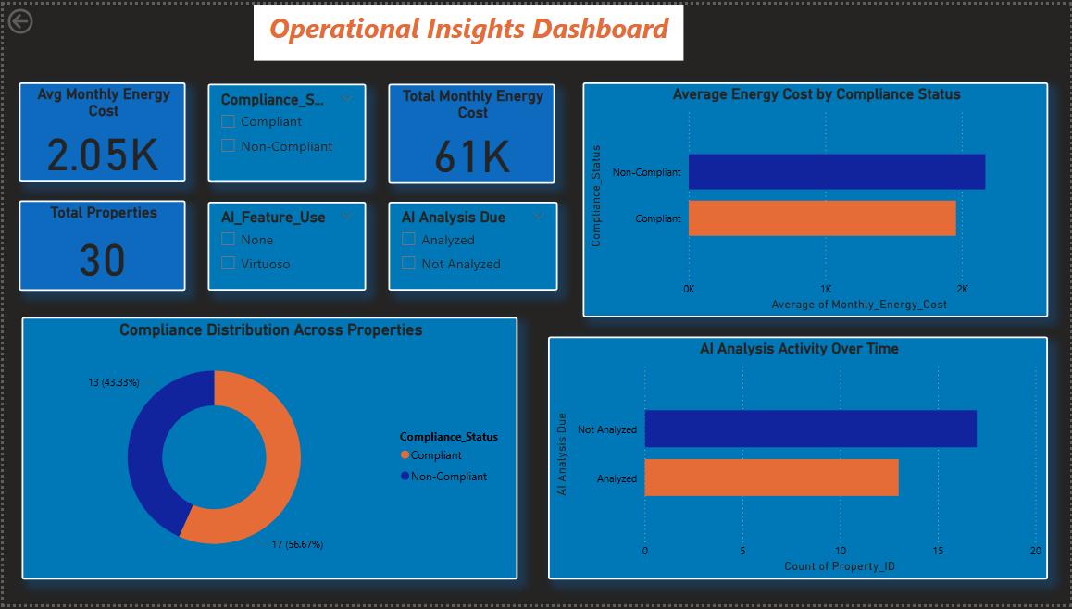

1. **Final Project Summary**

Summarizes key KPIs — total revenue, average occupancy, AI usage, compliance rate and maintenance efficiency.

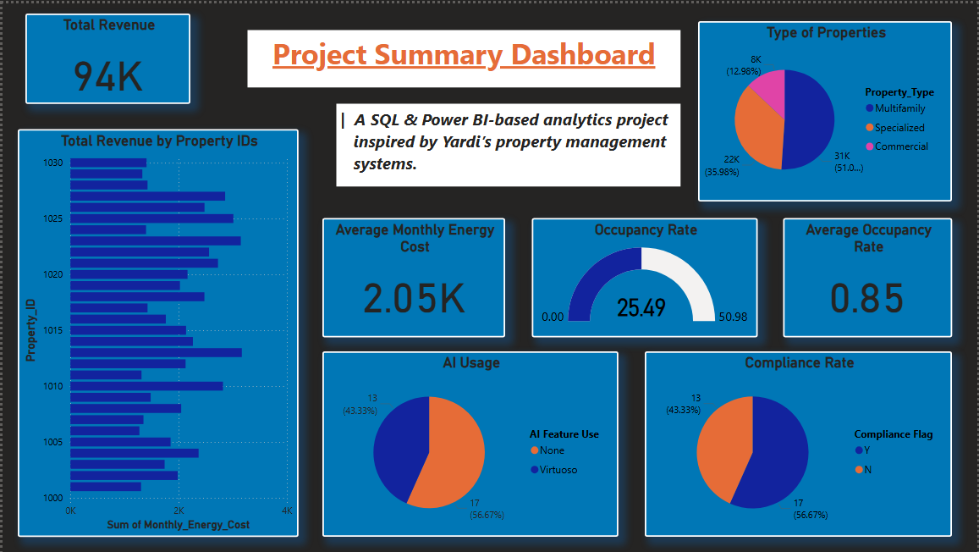

**SQL QUERIES & INSIGHTS**

1. **Compliance Not Updated for 90+ Days**

**Query:**

SELECT Property_ID, Address, Compliance_Flag, Last_AI_Analysis

FROM Property_Management

WHERE Compliance_Flag = 'N'

AND (

Last_AI_Analysis = 'NA'

OR (DATEDIFF(CURDATE(), Last_AI_Analysis) > 90)

);

**Insight:**  
Identifies properties that have not undergone compliance analysis for more than 90 days — indicating audit risk.

#### ****AI Feature Use vs Compliance****

**Query:**

SELECT Property_ID, Address, AI_Feature_Use, Compliance_Flag

FROM Property_Management

WHERE AI_Feature_Use IS NOT NULL

AND Compliance_Flag = 'N';

**Insight:**  
Finds properties using AI tools but still marked non-compliant — revealing gaps in AI effectiveness.

#### ****Highest Occupancy Property****

**Query:**

SELECT Property_ID, Address, Occupancy_Rate

FROM Property_Management

ORDER BY CAST(REPLACE(Occupancy_Rate, '%', '') AS DECIMAL) DESC

LIMIT 1;

**Insight:**  
Highlights the top-performing property based on occupancy — useful for benchmarking performance.

#### ****Average Occupancy Rate by Property Type****

**Query:**

SELECT Property_Type,

AVG(CAST(REPLACE(Occupancy_Rate, '%', '') AS DECIMAL)) AS Avg_Occupancy

FROM Property_Management

GROUP BY Property_Type;

**Insight:**  
Shows how occupancy rates vary between residential, commercial, and mixed properties.

#### ****Total Investment and Average Rent per Property Type****

**Query:**

SELECT Property_Type,

SUM(Investment_Value) AS Total_Investment,

AVG(Rent_Monthly) AS Avg_Rent

FROM Property_Management

GROUP BY Property_Type;

**Insight:**  
Evaluates capital allocation and revenue generation patterns by property type.

#### ****Properties with Above-Average Energy Costs****

**Query:**

SELECT Property_ID, Address, Monthly_Energy_Cost

FROM Property_Management

WHERE Monthly_Energy_Cost > (

SELECT AVG(Monthly_Energy_Cost)

FROM Property_Management

);

**Insight:**  
Flags cost-heavy properties to target energy optimization.

#### ****Count of Open Maintenance Tickets****

**Query:**

SELECT COUNT(*) AS Open_Tickets

FROM Property_Management

WHERE Maintenance_Status <> 'Resolved';

**Insight:**  
Tracks the number of unresolved service tickets — a key operational efficiency metric.

#### ****Top 3 Frequent Maintenance Issues****

**Query:**

SELECT Maintenance_Issue, COUNT(*) AS Issue_Count

FROM Property_Management

GROUP BY Maintenance_Issue

ORDER BY Issue_Count DESC

LIMIT 3;

**Insight:**  
Shows recurring maintenance challenges for preventive maintenance planning.

#### ****Average Sustainability Score by Energy Solution Status****

**Query:**

SELECT Energy_Solution_Enabled,

AVG(Sustainability_Score) AS Avg_Score

FROM Property_Management

GROUP BY Energy_Solution_Enabled;

**Insight:**  
Compares sustainability performance between properties that use energy-efficient solutions and those that don’t.

**Summary:**

These SQL queries provided insights into property performance, operational efficiency, and sustainability impact. Together, they formed the analytical foundation for the Power BI dashboards built for this project.

### ****Key KPIs****

* **Average Occupancy Rate:** 85%
* **Total Revenue:** 94K
* **Average Rent:** 3.31K
* **Total Monthly Energy Cost:** 61K
* **Total Net Profit:** 32K
* **Use of AI Features:** 43.33%

### ****Outcome:****

This project replicates real-world property analytics — showcasing how SQL can derive operational insights, optimize compliance, and drive business efficiency for property managers using Yardi systems.